POWER TEAM

Test 1

17-03-022

David njuguna

Purity Chepngeno

Kennedy

Objective

Familiarizing with electronic components, in order to study the basic architecture of electronic components

Determining the torque production by each motor

Theory

With the requirement of basic components such as the:

1.power source (ac to dc converter)

2.bldc motors and blades

3. electronic speed controller

4.arduino control board

We were able to conduct various test on the motors, the motor used was a 935kv rating motor, coupled with a 12v power supply it had a maximum rpm of around 11000rpm, this is seemingly about more than enough to provide the required torque for thrust. With the aid of the arduino board and the pulse modulation circuit unit on the board we were able to control and vary the speed of the motors. We also used c++ code to help vary the speed range and control the motors. See a copy of the code below.

Electronic components used and circuit connections

The electronic components used include:

1.power source (ac to dc converter)

2.bldc motors and blades

3. electronic speed controller

4.arduino control board

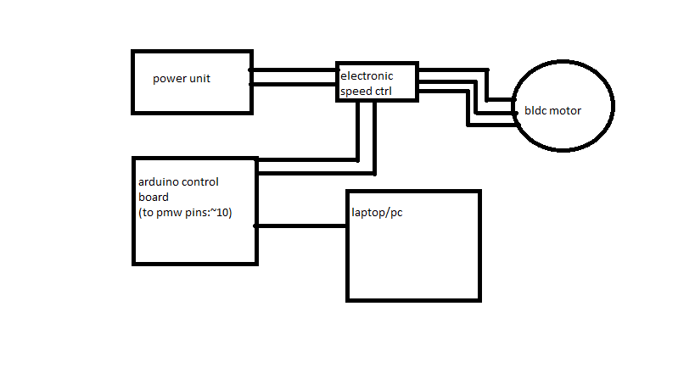

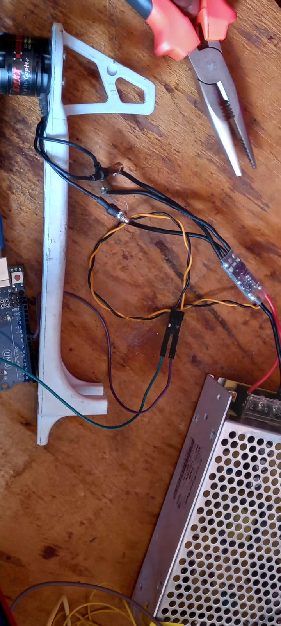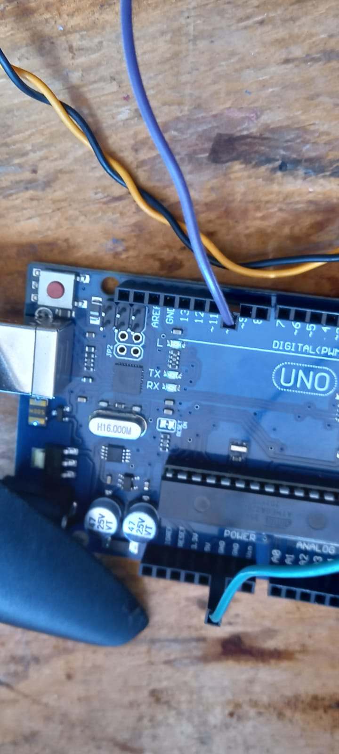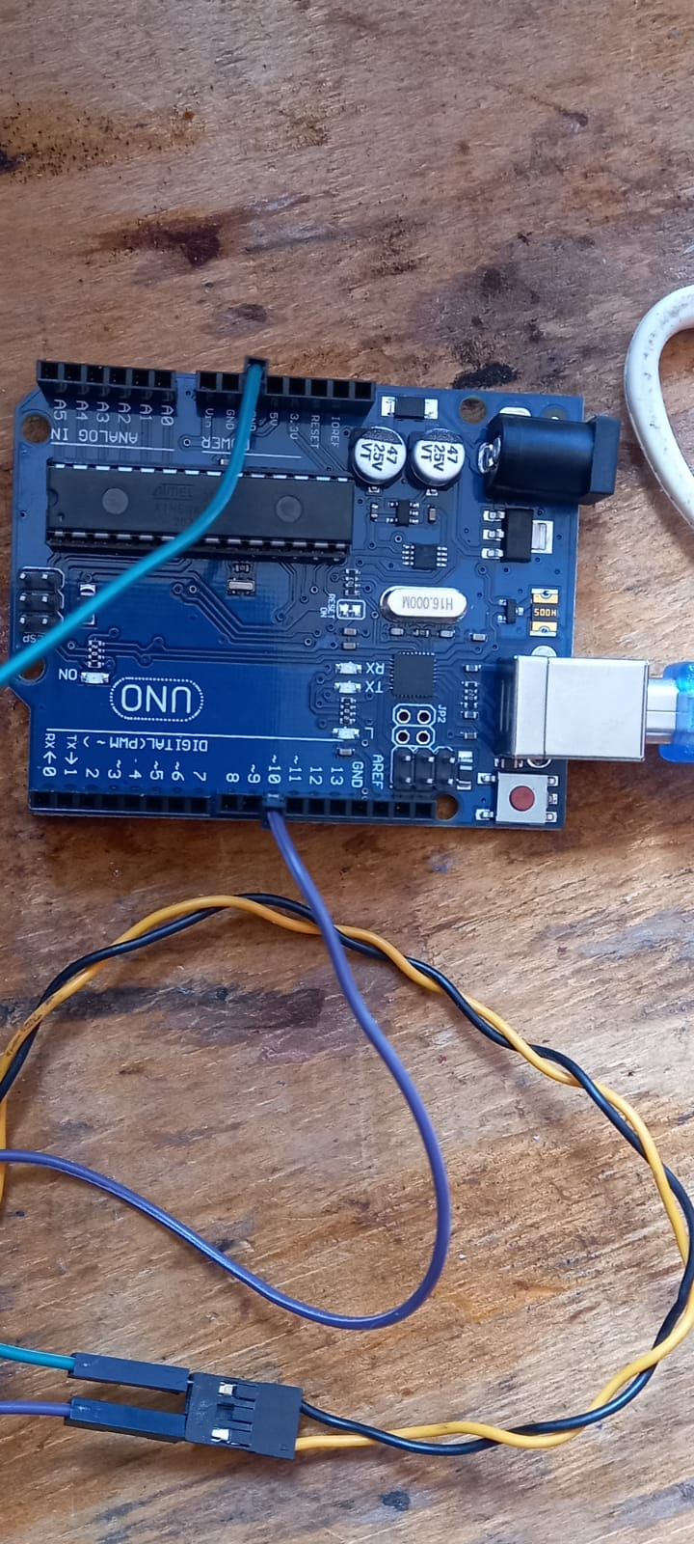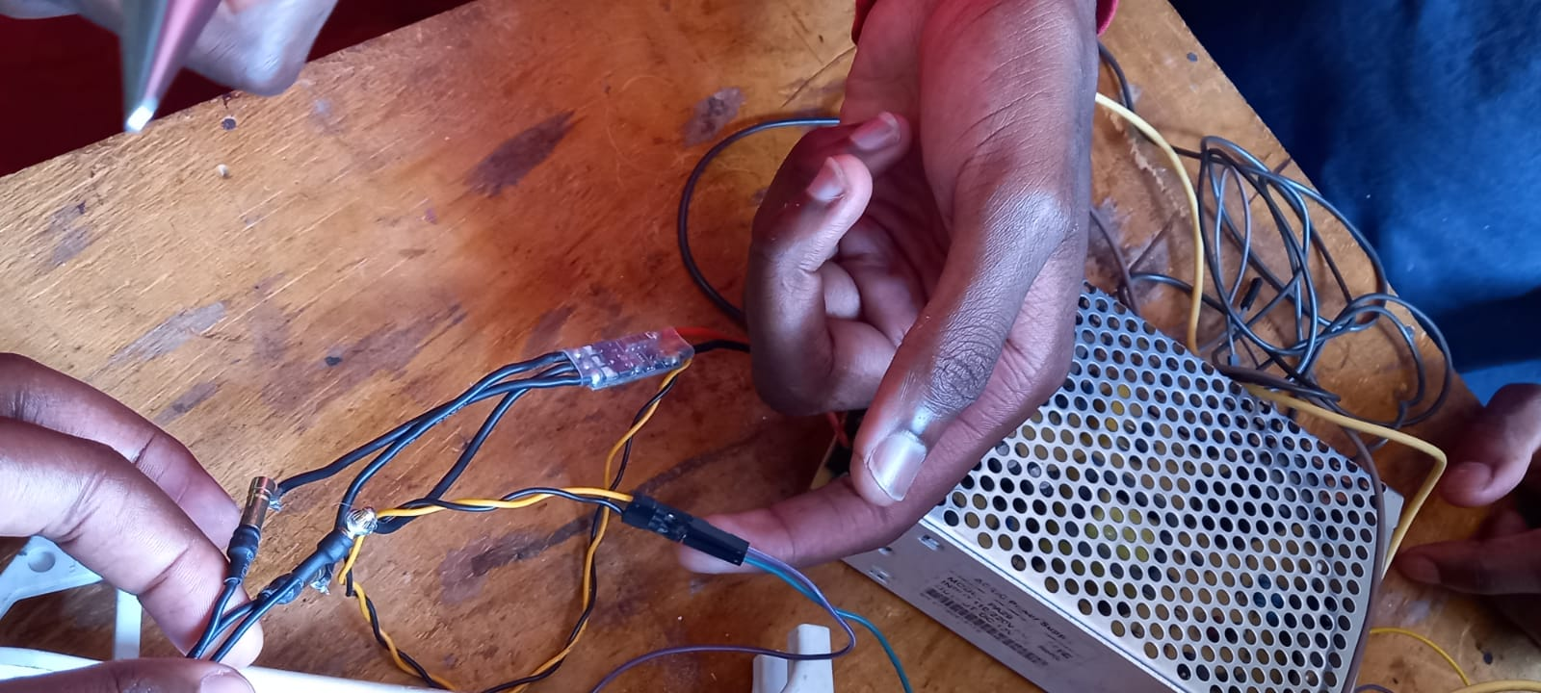

The electronics components were connected as shown above

Explanation

A brief explanation of each component and their function:

1.Motor

The brushless dc motor is a great choice for drone and Rc planes this is because of their quick response time and their high torque and speed. For our motor we used a 935kv motor capable of reaching up to 11000rpm when coupled with a 12v power supply.

In order to calculate the maximum rpm of the motor we multiply the kv rating with the voltage of the power source. The motor also comes with a propeller which comes with a specific size and pitch. For our test we used a (1045) R propeller that is a 10-inch propeller. The 45 indicates the pitch in which for our case the plane moves 4.5 inches for every revolution of the blade. The R indicates that the blade should be mounted on a counterclockwise rotating motor.

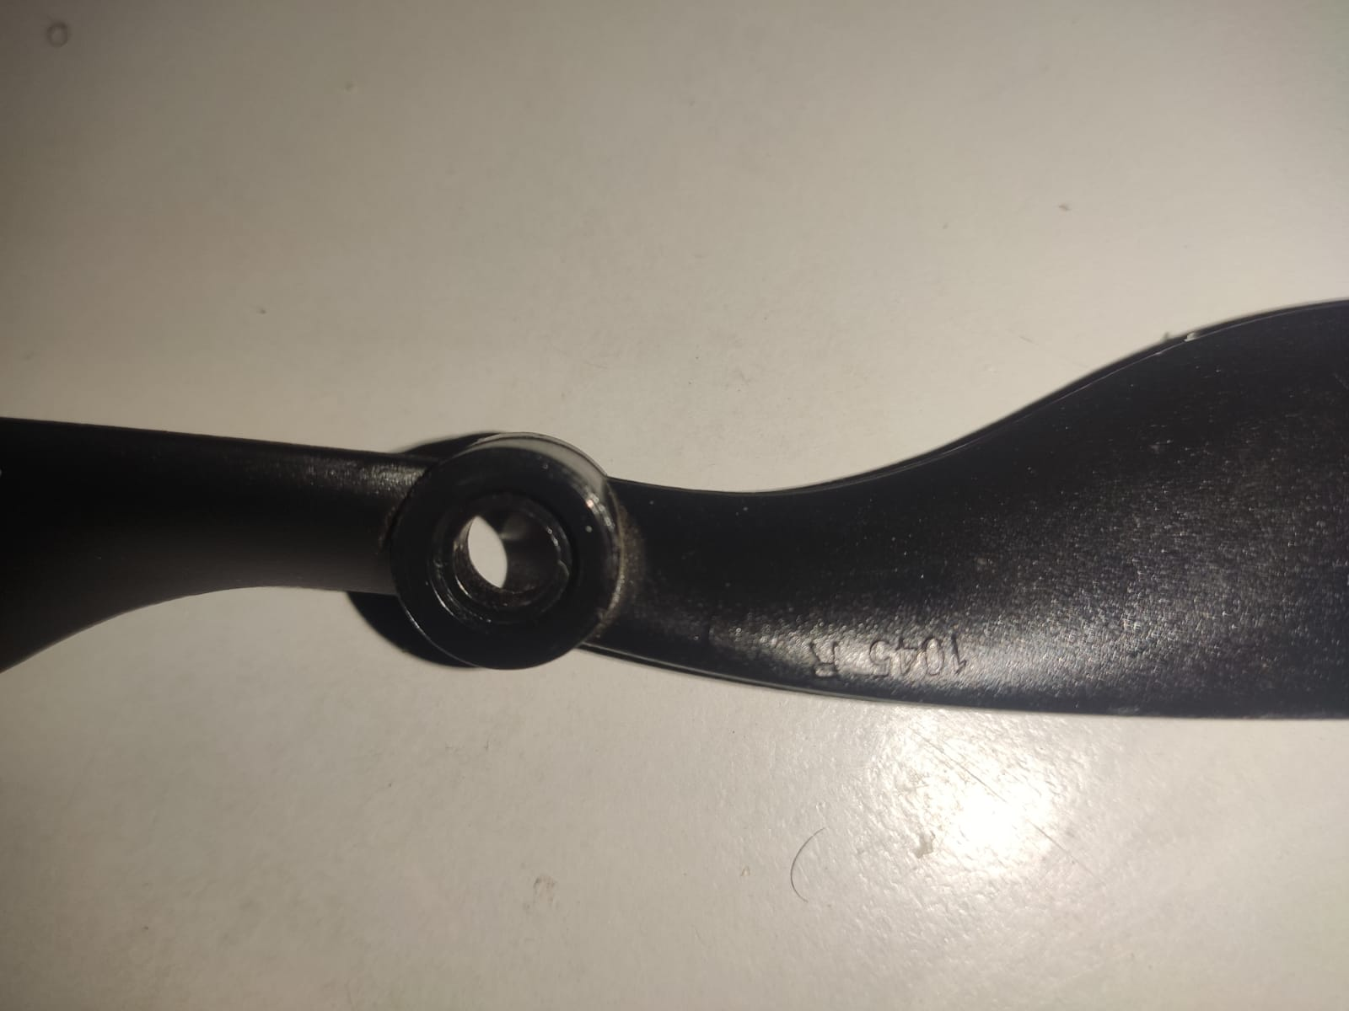

2.Electronic speed controller

The brushless dc motor cannot run without being connected to a speed controller. This is because the motor works when current is passed in different wire terminals with time in order to vary the magnetic flux and thus induce movement. For this reason, the esc bridges the motor to the power supply and to the arduino control board.

Power supply

For the case of testing, we found it safer to use an ac to dc converter. However, we plan to work with an 11v lithium polymer battery. The power supply is connected directly the esc.

3.Arduino control unit

The arduino board creates the platform for power and speed control. The esc connects directly to the arduino board via the ~pmw pins and the ground pins. By using the ~pmw pins we can easily vary the speed of the motor by using the pulse width modulation and also with the help of code.

Finally, all these processes are coordinated with code that we setup with the help of a pc. For our case we used c++ code with the help of the arduino IDE. A copy of the code is as shown below.

